EQUIPMENT LIST

Below is a list of MANDATORY equipment that is required for you to have for practice. If you already own these exact makes/models, then you are fine. Otherwise you need to purchase the items you do not currently own.

Please attach this order form along with your check (Made out to SEA) or you can have your credit card charged as well. Email your orders to Tina Cieri at teammanager@thedolphins.org.

Contact Info: 831-236-6612, text/call or you can email me with any questions at teammanager@thedolphins.org

If for some reason you are unable to purchase these items, please let me know.

PLEASE CHOOSE 1ST, 2ND AND 3RD CHOICES IN THE SPECIFIED COLORS.

SPORTI PULL BUOY $8.00 PLEASE CIRCLE COLOR $
Required for: All coaches

SPORTI KICKBOARD $11.00 PLEASE CIRCLE COLOR $
Required for: All Coaches

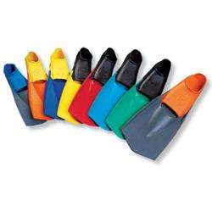TYR FINS EBP Burner $32.00 PLEASE CIRCLE SIZE $
Required for: All Coaches I HAVE FINS TO TRY ON FOR SIZE XS S M L XL

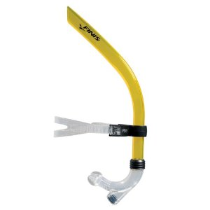 FINIS SNORKEL $30.00 $ Required for: Coach Ken, Coach Brian, Coach Jenny
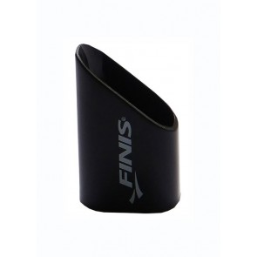 SNORKEL CAPS $5.00 $
Required for: Coach Ken only
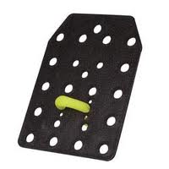 HANS PADDLES $10.00 $
Required for: Coach Ken only
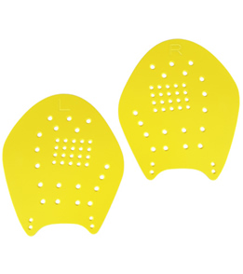 STROKEMAKER PADDLES $18.00 $ Required for: Coach Ken and Coach Brian, Coach Jenny
Please see me for sizing or ask your coach

EQUIPMENT LIST CONTINUED
PAGE 2

SPORTI EQUIPMENT BAGS $6.00 PLEASE CIRCLE COLOR $
Required for: All coaches

TOTAL AMOUNT DUE $

SWIMMER’S NAME: COACH:

EMAIl: PHONE#

OFFICE USE ONLY

RECEIVED DATE: AMOUNT RECEIVED:

PAID BY: CHECK CASH CC

EQUIPMENT DELIVERED ON :

NOTES:

